GuideXP TechLauncher Group Meeting Minutes

Meeting No. 3

12:30pm, Student Commons

March 26, 2019

# Attendees:

# Liang Hong u6303287

Rutai Sun u6227336

Danny Feng u6611178

Yuanze Niu u6401780

Yu Qiu u6063921

Kelin Zhu u5746358

# Agenda:

1): Discuss about the architecture of the project.

2): Determine the processes of different parts.

# Discussions

* We determine our log in page which consists the artists’ log in page and the administrator log in page.
* The artist will then move to the artists’ web page, the artist can upload their art documents which will be stored in the database.

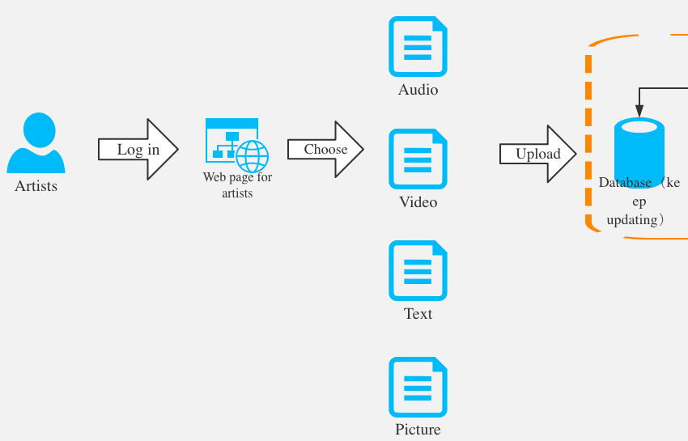

* The administrator will move to the manager page and have access to the database, to audit the documents that the artist upload can be upload on the webpage.

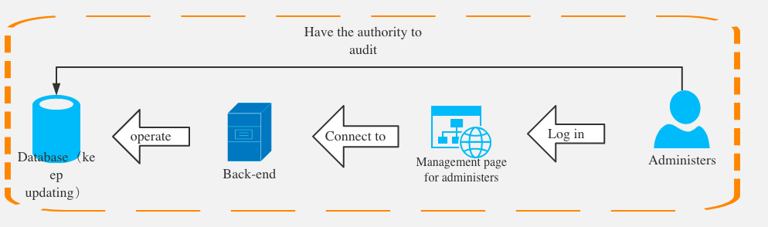

* The files that have been audited will be uploaded to users’ website.